26.46: The current gets split evenly between all the parallel bulbs. A single bulb will draw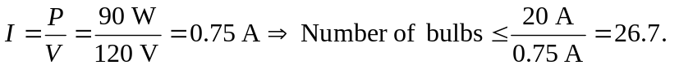So you can attach 26 bulbs safely.

